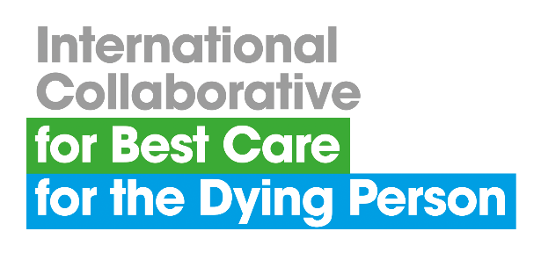 **ABSTRACT SUBMISSION PROFORMA**

**Submission deadline Sunday 15 September 2024**

**Please email your completed proforma to**

**admin@bestcareforthedying.org**

**9th Annual Conference on Best Care for the Dying Person**

**Porto, Portugal, 13-14 November 2024**

**Abstracts are invited for presentation (oral or poster) on topics relating to research and innovation in palliative and end of life care.**

|  |  |  |
| --- | --- | --- |
| **Oral/Poster presentation** | |  |
| **Organisation name** |  | |
| **Organisation address** |  | |
| **Contact email** |  | |
| **Contact telephone** |  | |
| **Title** |  | |
| **Author(s)** |  | |
| **Background** |  | |
| **Aim(s)** |  | |
| **Method(s)** |  | |
| **Results** |  | |
| **Conclusion(s)** |  | |

**Please refer to the abstract submission guidance overleaf before completing the proforma.**

**GUIDANCE FOR ABSTRACT SUBMISSION**

**SUBMISSION**

* The abstract submission proforma must be used for all submissions.
* Abstracts must be prepared in English and submitted via email to the following address: [admin@bestcareforthedying.org](mailto:admin@bestcareforthedying.org)
* Confirmation of receipt, including an abstract reference code, will be sent to the e-mail address provided with the submission.

**CONTENT OF ABSTRACT SUBMISSION**The title should be brief, using a maximum of 15 words, and should clearly indicate the nature of the investigation.

* Full names should be used and the first author should be the presenting author.
* Affiliations must include the name of the institutional affiliation, city and country.
* Abstracts should contain no more than 250 words (excluding author details).
* Please ensure whole words are used rather than abbreviations or special characters.

**NOTIFICATION**

* All abstracts submitted for oral or poster presentation will be reviewed and selected by the members of the conference organising team.
* Author notification will be made in due course using the email address included on the submission proforma.

**POSTER PRESENTATION**

Maximum Poster Size: A0

Format: Portrait

**CONTACT**If you would like to discuss abstract submission with a member of the conference organising team, please contact the Coordinating Centre Administrator on +44 (0)151 794 8886 or email [admin@bestcareforthedying.org](mailto:admin@bestcareforthedying.org)

**Deadline for abstract submission: 15 September 2024**